** **

**RAMKRISHNA MISSION VIDYAMANDIRA**

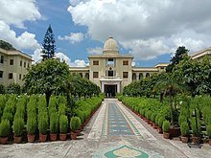

Name :- Sayan Mandal

Roll:- 259

Sub:- Value Education

Topic:- “Service to Man ,Service to God”

**Department**:- COMPUTER SCIENCE

**VHABAN**:- VINOY